**Nike Sales Analysis**

**SME: ABHI SAKLECHA**

**TRAINER: DINESH KARTHIK**

**GROUP MEMBERS:**

SAGAR CHAUDHARI (GL)

ARUN (GL)

SAI KUMAR SAPARE

SHIVANI KAPPATI

VAIBHAV SINGH

DHARUN BALAJI

**TABLE OF CONTENTS**

|  |  |  |
| --- | --- | --- |
| **Chapter No** | **Title** | **Page No** |
| 1 | Abstract | 1 |
| 2 | Introduction | 2 |
| 3 | Flowchart | 3 |
| 4 | Data cleaning | 5 |
| 5 | Informatica Intelligent Cloud Services | 9 |
| 6 | Snowflake | 12 |
| 7 | Tableau visualizations | 20 |
| 8 | Dashboard | 30 |
| 9 | Burndown chart | 37 |
| 10 | Kanban board | 39 |
| 11 | Conclusion | 40 |

1. **ABSTRACT**

Our project focused on analysing Nike's sales data using a comprehensive dataset containing 30,088 rows of detailed sales information. The primary objective was to transfer and transform this data from our source system, Oracle, to our target system, Snowflake, using Informatica Intelligent Cloud Services (IICS). This process involved extracting the raw sales data from Oracle, transforming it to ensure consistency and accuracy, and loading it into Snowflake for further analysis.

By leveraging IICS, we streamlined the ETL (Extract, Transform, Load) process, ensuring efficient and accurate data migration. The dataset covered various aspects of sales transactions, including product details, order information, and geographic data from 162 countries. This setup enabled us to perform in-depth sales analysis, uncovering valuable insights into sales trends, product performance, customer preferences, revenue drivers, and the impact of discounts on sales and profit margins.

In Snowflake, we utilized its robust cloud-based data warehousing capabilities to store and manage the transformed data. Snowflake's scalable architecture allowed us to handle large volumes of data efficiently, providing a flexible environment for running complex queries and generating detailed reports. The integration with Snowflake also facilitated seamless data sharing and collaboration among team members, enhancing our overall data management and analytical capabilities.

After the data was successfully loaded into Snowflake, we connected it to Tableau to create interactive worksheets and dashboards. Tableau's powerful visualization tools enabled us to transform the raw data into meaningful visual insights. We developed various visualizations, including sales trends over time, product performance by category, geographic sales distribution, and the impact of discounts on sales and profit margins. These visualizations provided a clear and intuitive way to explore the data, identify patterns, and make data-driven decisions.

The project successfully enhanced our data management capabilities, providing a scalable and flexible environment for generating actionable insights from Nike's sales data. This analysis will help us understand the factors contributing to Nike's sales success and identify opportunities for future growth.

1. **INTRODUCTION**

This project focuses on building an Dashboard using Python, Informatica Intelligent Cloud Services (IICS), Oracle, Snowflake, AWS S3, and Tableau. The goal is to efficiently clean, transform, and visualize data by implementing a structured workflow that ensures seamless data flow from a raw CSV dataset to insightful dashboards in Tableau.

**Key Objectives:**

1. **Data Cleaning**: This involves removing null values and any unwanted columns to ensure your data is clean and structured, making it ready for analysis.
2. **Data Integration**: Using Informatica Intelligent Cloud Services (IICS) to map the data flow from a flat file to Oracle, and then to Snowflake, while ensuring that data is consistent and accurate throughout the process.
3. **Storage & Processing**: Setting up Snowflake for data storage and AWS S3 for unloading data, which provides scalable and secure storage solutions for large datasets.
4. **Data Visualization**: Utilizing Tableau to create interactive dashboards, enabling stakeholders to explore data visually and uncover actionable insights.
5. **FLOWCHART**

This flowchart represents the data processing workflow from raw data acquisition to visualization and integration with Snowflake. The process involves several steps, including data cleaning, ETL (Extract, Transform, Load) operations, and dashboard creation for data analysis and reporting**.**

1. Raw Data: The process begins with raw data stored in a database or source system.
2. Data Cleaning: The raw data undergoes a cleaning process to remove inconsistencies, duplicates, and errors. This step ensures data quality, preparing it for further processing.
3. Cleaned Data: After cleaning, the data is stored as "Cleaned Data," which is ready for transformation and analysis.
4. IICS ETL Process: The cleaned data is processed through an ETL pipeline using Informatica Intelligent Cloud Services (IICS). ETL (Extract, Transform, Load) involves extracting data from the source, transforming it based on business rules, and loading it into the Snowflake data warehouse.
5. Creating IAM Policy and Role in Snowflake: To ensure secure access and integration, IAM (Identity and Access Management) policies and roles are created in Snowflake.
6. Connecting Tableau to Snowflake: Tableau is connected to Snowflake to enable data visualization and reporting. This integration allows users to query and visualize data directly from the Snowflake database.
7. Tableau Sheets Creation: Individual Tableau sheets are created for specific data analysis tasks. These sheets contain various charts, graphs, and tables to represent data insights.
8. Dashboard Creation: The final step involves creating interactive dashboards in Tableau. Dashboards provide a comprehensive view of data trends, patterns, and metrics, facilitating decision-making.
9. **DATA CLEANING**

Step 1: Importing and Loading Data:

In the given image, we are working in a Jupyter Notebook using Python (Pydiode kernel). The dataset is loaded into a Pandas DataFrame from a CSV:

**df = pd.read_csv("Nike_UK_21`022-09-01.csv")**

This command is used to read the CSV file and store it in a Pandas DataFrame (df).

Step 2: Data Cleaning:

After loading the dataset, some data cleaning operations are performed like removing Null Rows:

**df.dropna(subset=["BRAND"], inplace=True)**

This line removes all rows where the "BRAND" column has null (NaN) values.

Step 3: Displaying the Data:

Finally, the DataFrame is printed to visually inspect the data:

**Print(df)**

Step 4: Data Cleaning:

After loading the dataset, some data cleaning operations are performed like removing Null Rows:

**df.dropna(subset=['PRODUCT_SIZE'], inplace=True)**

**print(df)**

This line removes all rows where the "PRODUCT_SIZE" column has null (NaN) values and then print the data frame.

Step 5: Dropping Unnecessary Columns:

The goal is to remove unnecessary columns that do not contribute to the data analysis process.

The dataset contains columns such as:

'SKU'

'SKU_VARIANT'

'COLOR_CODE'

'TID'

'PRODUCT_URL'

These columns are not relevant for further processing, so we remove them using the drop() function.

*df.drop('SKU', axis=1, inplace=True)*

*df.drop('SKU_VARIANT', axis=1, inplace=True)*

*df.drop('COLOR_CODE', axis=1, inplace=True)*

*df.drop('TID', axis=1, inplace=True)*

*df.drop('PRODUCT_URL', axis=1, inplace=True)*

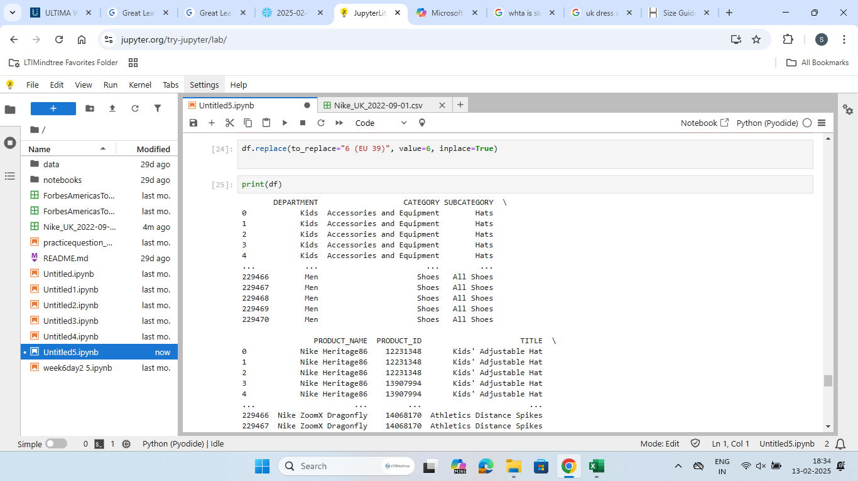

Step 6: Replacing Specific Values:

Here we perform a value replacement operation in the DataFrame using Pandas. This is essential for correcting specific data entries, such as replacing product size values with a uniform format.

We use the replace() function to change specific values in the dataset. In this case, the value "6 (EU 39)" is being replaced with a cleaner representation, "6", to maintain consistency across the PRODUCT_SIZE column.

**df.replace(to_replace="6 (EU 39)", value="6", inplace=True)**

1. **INFORMATICA INTELLIGENT CLOUD SERVICES**

Connecting Flat File to Oracle **:**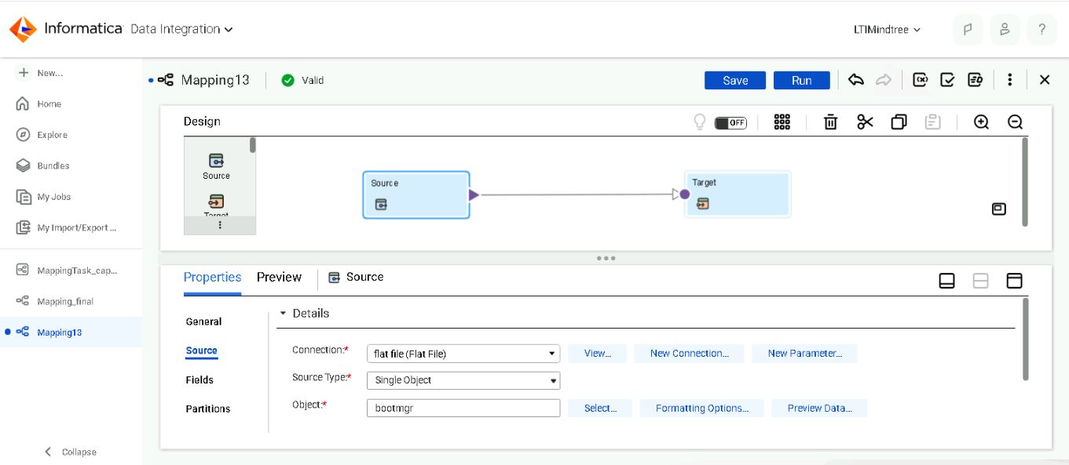

Configuring Source in Informatica IICS:

we configure a flat file (CSV) as the data source in Informatica Intelligent Cloud Services (IICS). The mapping interface shows a direct connection from the Source (Flat File)

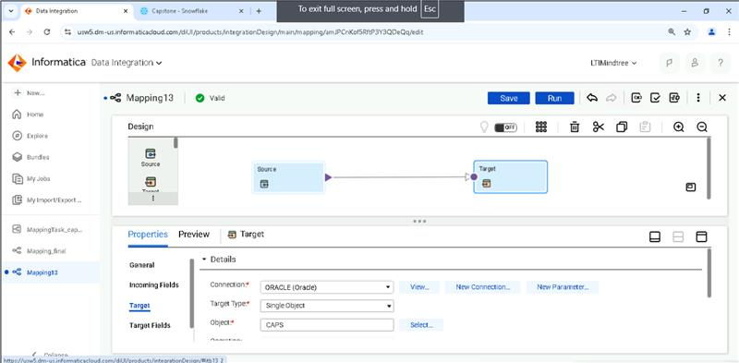

Setting Up Oracle as Target in IICS Mapping

Here we configure the target system in Informatica Intelligent Cloud Services (IICS), where the cleaned and transformed data will be stored. The target here is Oracle Database.

Connecting Oracle to Snowflake:

Here we configure a Oracle Table as the data source in Informatica Intelligent Cloud Services (IICS).

Here we configure the target system in Informatica Intelligent Cloud Services (IICS), where the cleaned and transformed data will be stored. The target here is Snowflake.

Notification of Success:

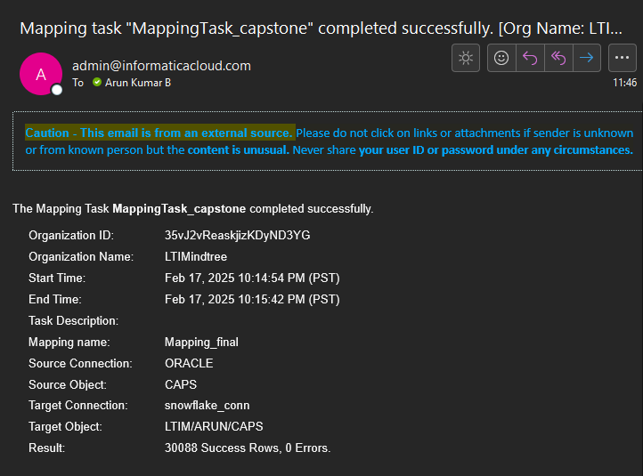

Email Notification for Successful Mapping Execution

This email confirms the successful execution of a mapping task in Informatica Intelligent Cloud Services (IICS). The system automatically sends an email notification upon completion of the mapping task, providing important details such as the task status, start and end time, source and target connections, and number of processed records.

1. **SNOWFLAKE**

Creating an S3 bucket in AWS is a fundamental step for storing and managing data in the cloud.

STEPS:

1. **Sign in to AWS Management Console:**

* Open your web browser and go to the AWS Management Console.
* Sign in with your AWS account credentials.

1. **Navigate to S3 Service:**

* In the AWS Management Console, click on "Services" at the top of the page.
* Under the "Storage" category, select "S3" to open the Amazon S3 console.

1. **Create a New Bucket:**

* In the S3 console, click on the "Create bucket" button.
* Bucket Name: Enter a unique name for your bucket. The name must be globally unique across all existing bucket names in Amazon S3.
* Region: Select the AWS region where you want to create the bucket. Choosing a region close to your users can help reduce latency and costs.

1. **Review and Create:**

* Review all the settings you have configured.
* Click on the "Create bucket" button to create your new S3 bucket.
* Bucket Created: Once the bucket is created, you will be redirected to the bucket's overview page where you can start uploading objects, configuring permissions, and managing bucket settings.

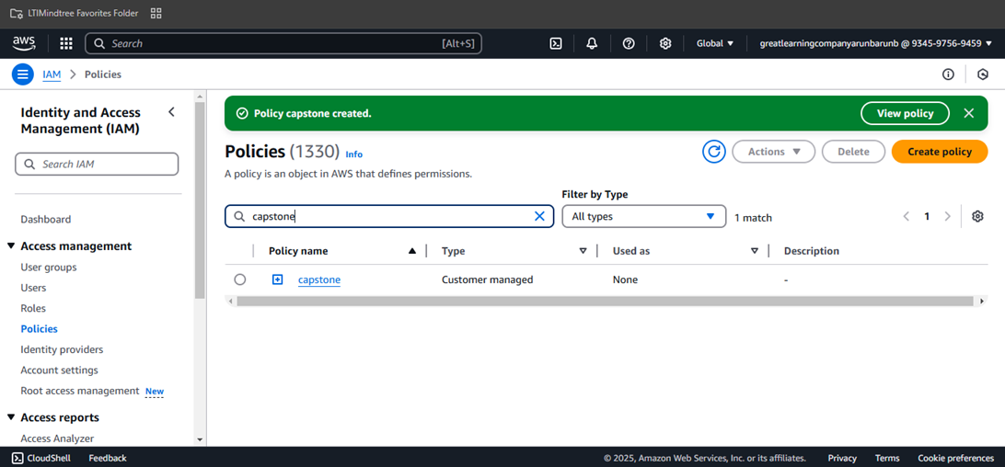

IAM policies are used to define permissions for users, roles, and services in AWS. These policies help control access to AWS resources by specifying what actions are allowed or denied.

* + The policy name is “capstone”.
  + The policy type is Customer Managed, meaning it was manually created.
  + The policy is currently not assigned to any user, group, or role
  + The right panel shows that the policy was successfully created.
  + Options available: View policy, delete policy, or create a new policy.
  + This IAM policy is likely used to grant permissions for AWS services involved in the project.
  + If this policy is associated with an IAM Role, it can be used for services like **Snowflake, S3

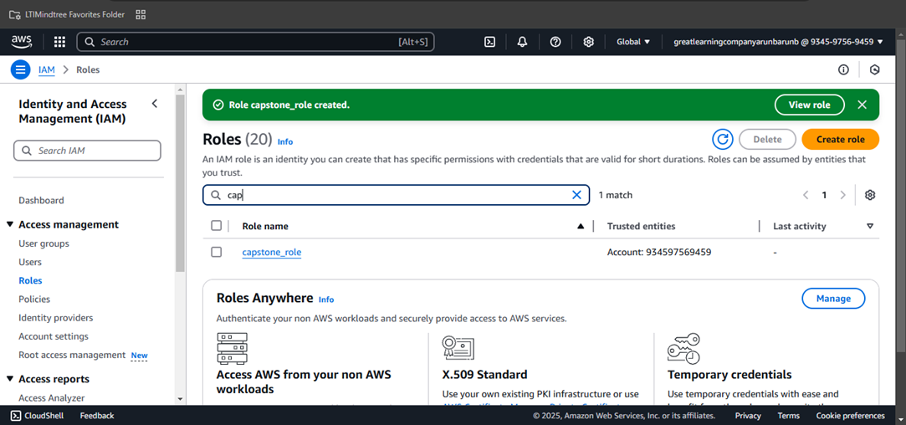

IAM roles are used to delegate permissions to AWS services or users. Instead of assigning permissions directly to users, roles allow temporary access to AWS resources through trusted entities.

* + The role “capstone_role” has been successfully created.
  + This role is trusted by AWS account 934597569459, meaning it can be assumed by entities within this account.
  + The green notification confirms that the role was created successfully.
  + The “View role” button allows further inspection of permissions and trust policies.
  + Options available: Delete role, create new role, or Manage settings.
  + The capstone_role will likely be used to grant permissions for AWS services such as S3, Snowflake, Lambda, EC2, or Glue.
  + This role is essential for ensuring secure and controlled access without requiring hardcoded credentials.
  + It is expected that the role will be linked to an IAM policy (e.g., “capstone” policy) to define the allowed actions.

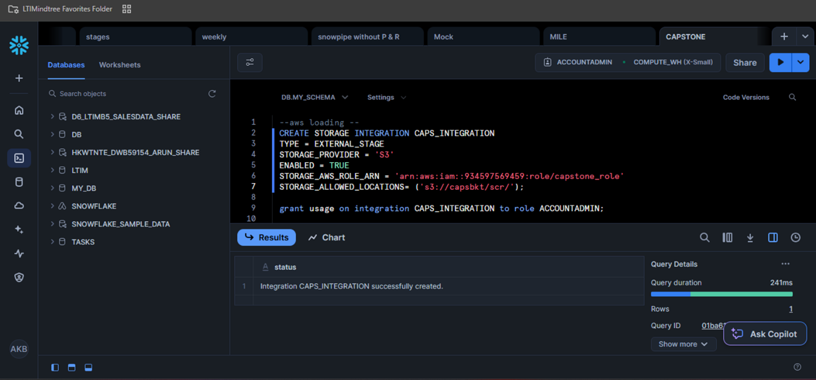

CREATE STORAGE INTEGRATION CAPS_INTEGRATION: This is the command to create the storage integration. CAPS_INTEGRATION is the name given to this specific integration.

TYPE = EXTERNAL_STAGE: Specifies that this integration is for accessing external cloud storage.

STORAGE_PROVIDER = S3: Indicates that the external storage is on Amazon S3.

ENABLED = TRUE: Activates the integration.

STORAGE_AWS_ROLE_ARN = 'arn:aws:iam::934597569459:role/capstone_role': This is a crucial line. It provides the Amazon Resource Name (ARN) of an AWS IAM role. This role defines the permissions that Snowflake has to access the S3 bucket. Essentially, you create a role in AWS that has specific permissions to read from your S3 bucket, and then you provide the ARN of that role to Snowflake.

STORAGE_ALLOWED_LOCATIONS = ('s3://capsbkt/scr/'): This specifies the S3 bucket and path that Snowflake is allowed to access. s3://capsbkt/scr/ means Snowflake can access objects within the scr folder in the capsbkt S3 bucket.

grant usage on integration CAPS_INTEGRATION to role ACCOUNTADMIN =This command grants the ACCOUNTADMIN role in Snowflake the privilege to use the CAPS_INTEGRATION. Roles are used to manage permissions in Snowflake. By granting usage to the ACCOUNTADMIN role, users with that role (likely administrators) can then use this integration to load data.

Enabled = true

Storage_aws_role_arn = 'arn:aws:iam::934597569459:role/capstone_role'

Storage_allowed_locations = ('s3://capsbkt/scr/')

* + This section defines an aws storage integration in snowflake.
  + Enabled = true: enables the integration.
  + Storage_aws_role_arn: specifies the aws iam role (capstone_role) used to access s3.
  + Storage_allowed_locations: defines the allowed s3 storage path (s3://capsbkt/scr/)

Desc integration caps_integration:

* This command describes the storage integration named caps_integration, retrieving its properties.

List @caps_loading:

* This command lists the files available in the snowflake staging area called caps_loading.

Create table caps2 like caps:

* This creates a new table caps2 with the same structure as the existing table caps but without data.

**CREATE PIPE CAPS_PIPE**

* This starts defining a Snowpipe, which is an automated data ingestion pipeline in Snowflake.

Create table caps2 like caps: This command creates a new table CAPS2 with the same structure as the existing table CAPS. This is often done to create a target table for the ingested data.

CREATE PIPE CAPS_PIPE: This is the core command to create the pipe.

AUTO_INGEST = TRUE: This is crucial. It enables automatic ingestion, meaning the pipe will automatically load new data files as they appear in the cloud storage location specified by the stage.

AS COPY INTO: This defines what happens when the pipe runs.

COPY INTO DB.MY_SCHEMA.CAPS2: This specifies that data will be copied into the CAPS2 table.

FROM @DB.MY_SCHEMA.CAPS_LOADING: This indicates the data source is the stage CAPS_LOADING. The @ symbol signifies it's a stage.

FILE_FORMAT = (TYPE = CSV): This specifies that the data files in the cloud storage are in CSV format.

Desc pipe caps_pipe: This command describes the pipe, showing its configuration and status.

SELECT FROM CAPS2: This query retrieves and displays the data that has been loaded into the CAPS2 table.

**Upload Process**

Step 1: Navigate to the AWS S3 console and select the created bucket name Step 2: Click on the "Upload" button.

Step 3: Drag and drop the Nike sales dataset CSV file or click "Add files" to select the file from your local system.

Step 4: Configure the upload settings if needed (e.g., storage class, encryption).

Step 5: Click "Upload" to start the upload process.

Step 6: Once the upload is complete, verify that the file appears in the bucket.

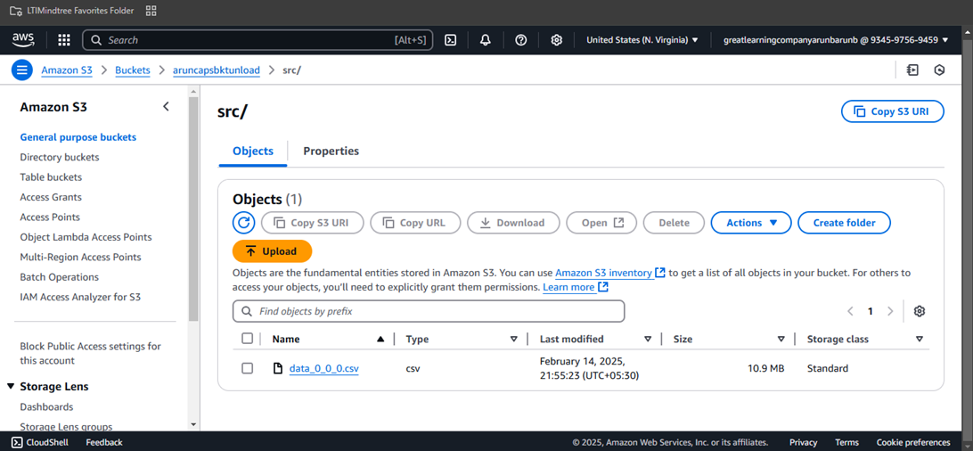

Unloading Data Using the COPY INTO Command

Command: Use the COPY INTO command to unload data from a Snowflake table into your S3 bucket.

*COPY INTO @my_s3_stage/my_data.csv*

*FROM my_table*

*FILE_FORMAT = (TYPE = CSV FIELD_OPTIONALLY_ENCLOSED_BY = '"')*

*HEADER = TRUE;*

This command copies data from the specified Snowflake table (my_table) into a CSV file (my_data.csv) in your S3 bucket. The FILE_FORMAT parameter specifies the format of the output file, in this case, CSV. The HEADER parameter indicates that the first row of the output file should contain column headers.

Verifying the Unloaded Data

Check S3 Bucket: Navigate to your S3 bucket and verify that the data file (my_data.csv) has been successfully uploaded.

Explanation: After executing the COPY INTO command, you should check your S3 bucket to ensure that the data file has been uploaded correctly. This step involves logging into your AWS S3 console, navigating to the specified bucket, and verifying the presence and contents of the file.

After unloading the data has been shared to everyone in the team through private sharing

1. **TABLEAU VISUALIZATIONS**
2. SALES TREND ANALYSIS:

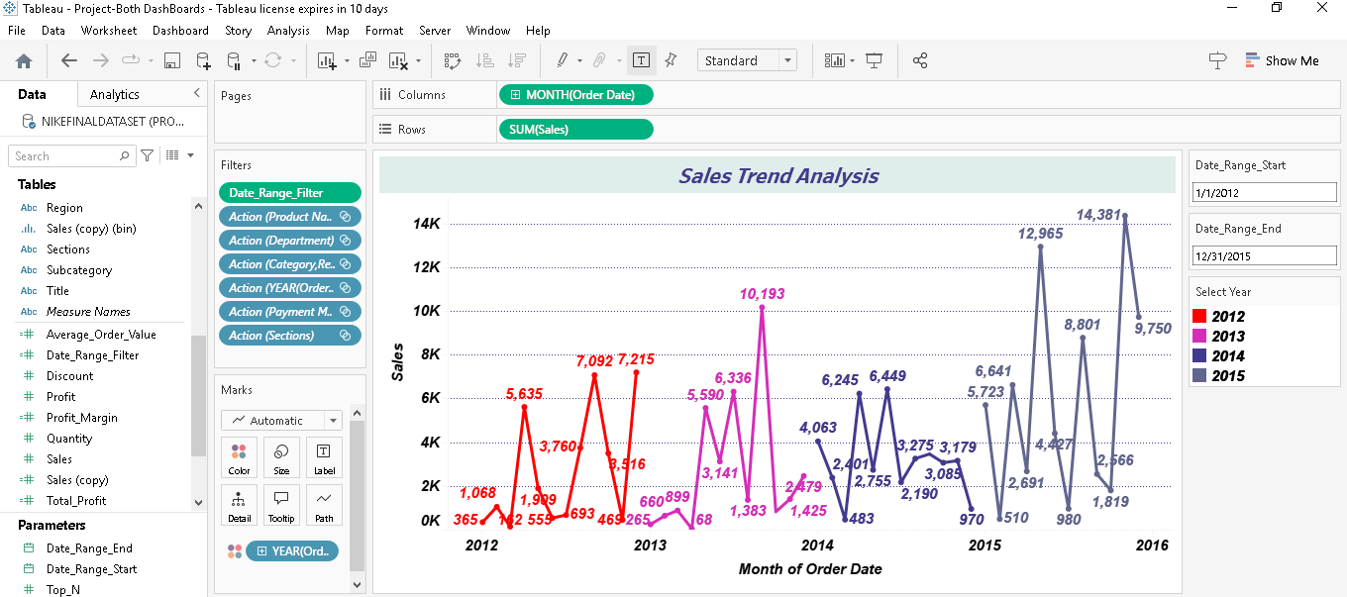

* Purpose of a sales trend analysis line chart is to identify trends in sales data over time. This helps in understanding how sales are increasing, decreasing, or remaining stable.
* X-Axis (Horizontal Axis): Represents the time period (e.g., days, months, quarters, years).
* Y-Axis (Vertical Axis): Represents the sales figures (e.g., revenue, units sold).
* Data Points: Each point on the line chart represents sales data for a specific time period.
* Line: The line connects the data points, showing the trend over time.

1. TOP SELLING PRODUCT:

* A radial chart, also known as a radar chart or spider chart, is a graphical method used to display multivariate data in a way that allows for easy comparison of different variables.
* Axes: Each axis represents a different variable or category. In the context of top-selling products, each axis could represent a different product.
* Scale: The scale on each axis typically ranges from the centre (minimum value) to the outer edge (maximum value). For sales data, this could range from 0 to the highest sales figure.
* Data Points: Data points are plotted along each axis according to their values. For example, if Product A has high sales, its data point will be plotted further from the centre.
* Connecting Lines: Data points are connected by lines to form a polygon. The shape and size of the polygon give a visual representation of the performance of each product.

1. CUSTOMER DEMOGRAPHICS:

* Purpose of a customer demographics pie chart is to provide a visual representation of the distribution of various demographic section.
* Slices: Each slice of the pie chart represents a different demographic section
* Labels: Each slice is labelled with the demographic section it represents.
* Percentages: The size of each slice is proportional to the percentage of the total customer base that falls into that different section.

1. GEOGRAPHIC SALES DISTRIBUTION:

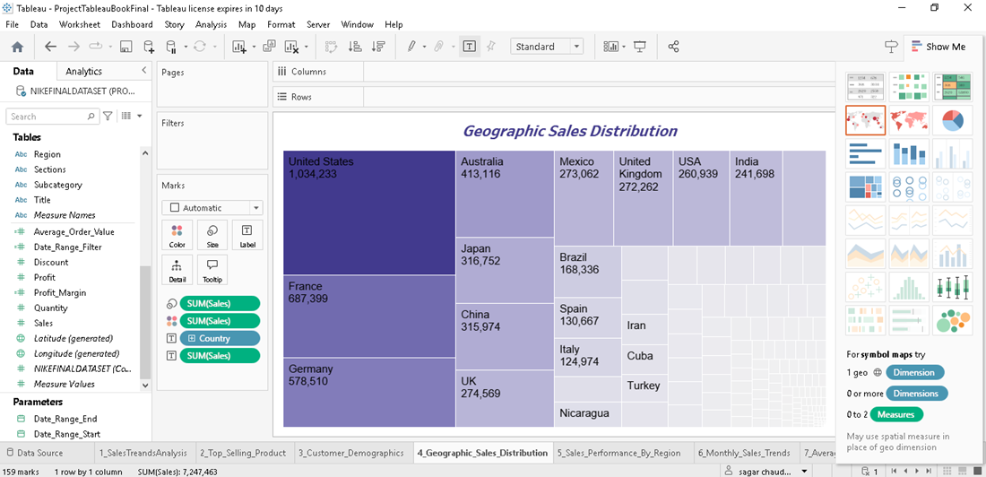

* The primary purpose of a geographic sales distribution tree map is to provide a visual representation of sales data across different geographic regions.
* Helps in identifying patterns and trends in sales performance across various locations.
* Assists in strategic planning by highlighting areas with high or low sales performance.
* Regions: Different geographic regions (e.g., countries, states, cities) are represented on the map.
* Colour Coding: Regions are color-coded based on sales performance. For example, darker colours may represent higher sales, while lighter colours represent lower sales.
* Legends: A legend is included to explain the colour coding and provide context for the data.
* Data Points: Specific data points, such as sales figures or percentages, may be displayed on the map.

1. SALES PERFORMANCE BY REGION:

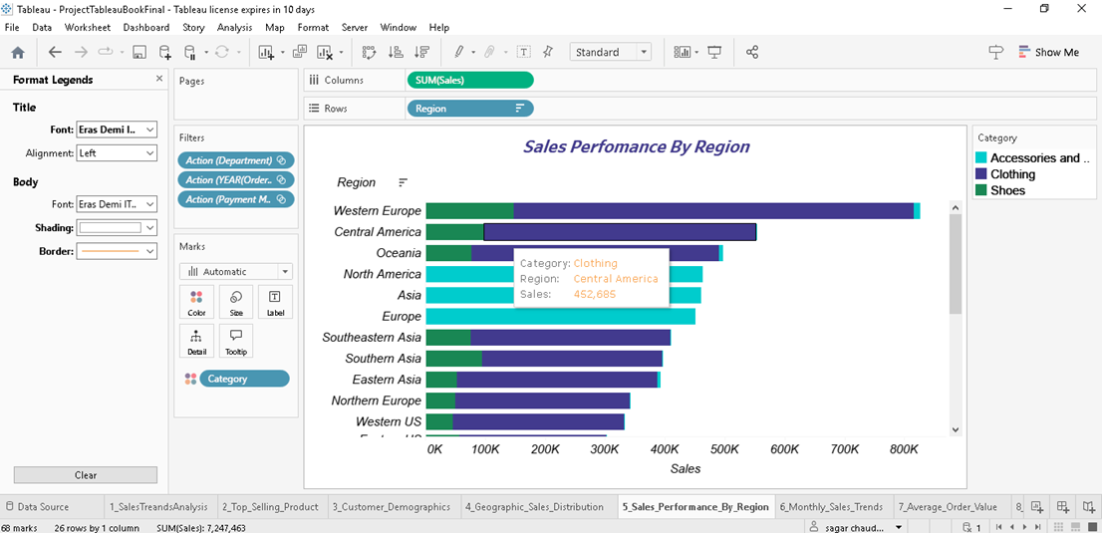

* The primary purpose of this bar chart is to compare sales performance across various regions
* X-Axis (Horizontal Axis): Represents the different geographic regions (e.g., countries, states, cities).
* Y-Axis (Vertical Axis): Represents the sales figures (e.g., revenue, units sold).
* Bars: Each bar represents the sales figure for a specific region. The length of the bar indicates the sales volume.
* Labels: Each bar is labelled with the region it represents and the corresponding sales figure.

1. MONTHLY SALES TREND:

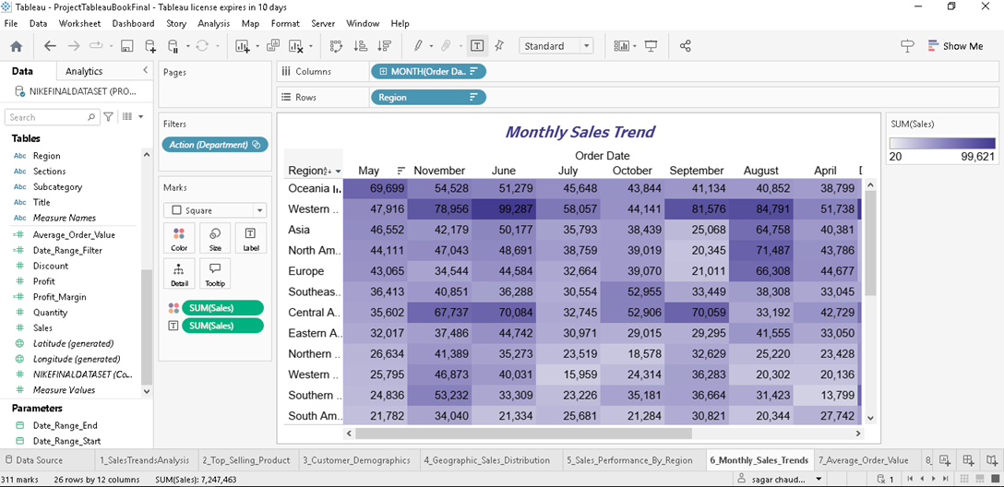

* The primary purpose of a monthly sales trends heat map is to provide a visual representation of sales data across different months.
* Grid Layout: The heat map is typically laid out in a grid format, with months on one axis (usually the X-axis) and another dimension (e.g., product categories, regions) on the other axis (usually the Y-axis).
* Colour Coding: Each cell in the grid is color-coded based on the sales performance for that month and dimension. Darker or more intense colours often represent higher sales, while lighter colours represent lower sales.
* Legends: A legend is included to explain the colour coding and provide context for the data.

1. AVERAGE ORDER VALUE (AOV):

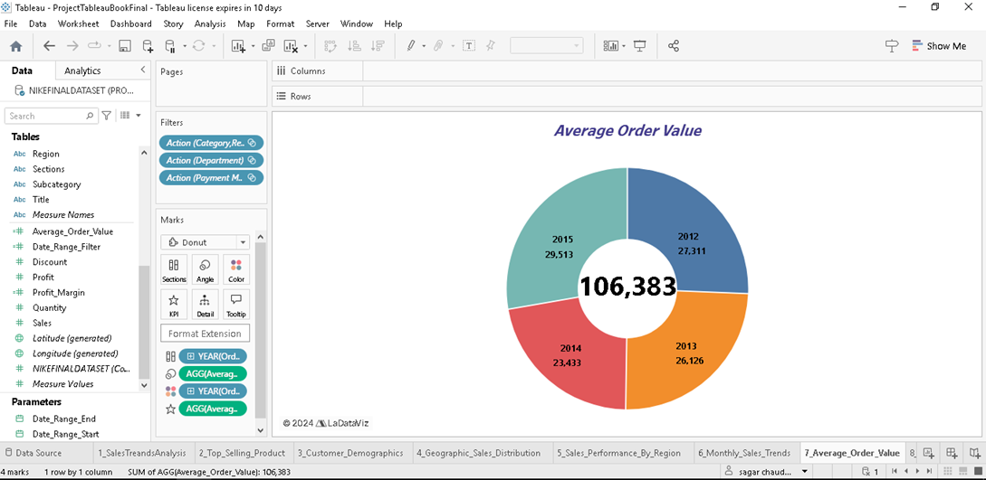

* The primary purpose of an AOV donut chart is to provide a visual representation of the average order value across different segments or categories.
* Helps in comparing the AOV across various product categories, customer segments, or time periods.
* Provides insights into customer purchasing behaviour and helps identify opportunities to increase AOV.
* Donut Shape: The chart is circular with a hole in the centre, making it visually distinct from a pie chart.
* Slices: Each slice of the donut represents a different segment (e.g., product category, customer segment).
* Labels: Each slice is labelled with the segment it represents and the corresponding AOV.
* Percentages: The size of each slice is proportional to the AOV for that segment.

1. SALES BY PAYMENT METHOD:

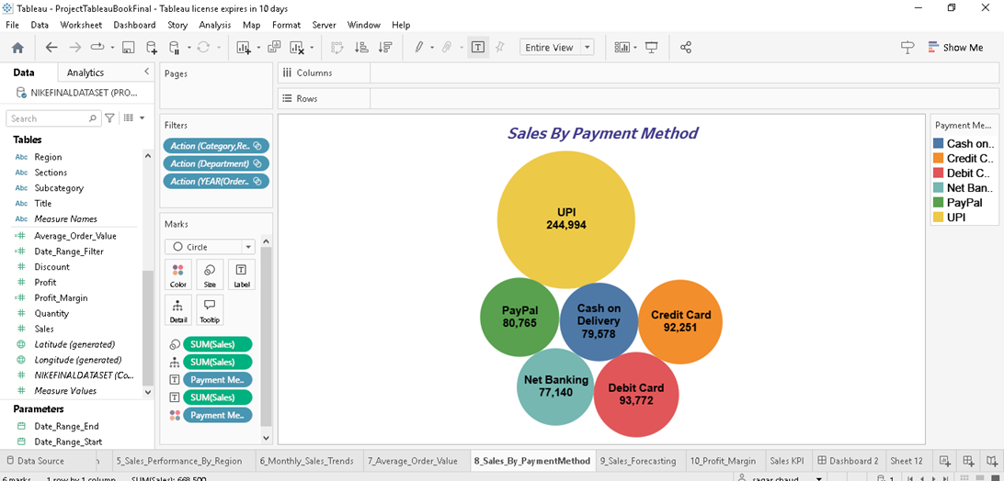

* The primary purpose of a sales by payment method bubble chart is to provide a visual representation of sales data across various payment methods
* Provides insights into customer preferences and the effectiveness of different payment methods.
* X-Axis (Horizontal Axis): Represents one variable, typically a quantitative metric such as the number of transactions or sales volume.
* Y-Axis (Vertical Axis): Represents another variable, such as the total sales revenue.
* Bubbles: Each bubble represents a different payment method. The position of the bubble on the X and Y axes indicates the values of the two variables.
* Bubble Size: The size of each bubble represents a third variable, such as the average order value (AOV) or the percentage of total sales.
* Bubble Colour: Optionally, the colour of the bubbles can represent a fourth variable, such as customer satisfaction or transaction fees.

1. SALES FORCASTING:

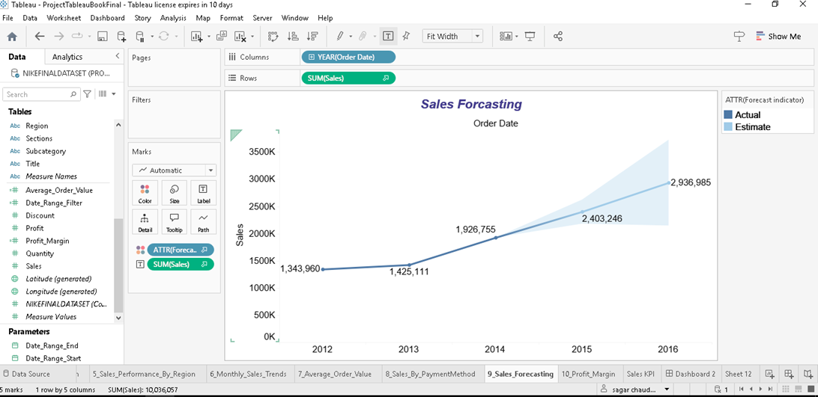

* Sales forecasting is the practice of estimating future sales for a business or product over a specific period. It involves analysing past sales data, market conditions, and other variables to make informed predictions about future sales performance. Accurate sales forecasting is essential for effective business planning, budgeting, and decision-making.
* Data Collection: Gather historical sales data and other relevant information, such as market trends, economic indicators, and competitor performance.
* Data Analysis: Analyse the collected data to identify trends, patterns, and relationships.
* Select Forecasting Method: Choose the most appropriate forecasting method based on the data and business context.
* Apply the Method: Use the selected method to generate sales forecasts.
* Validate the Forecast: Compare the forecasted sales with actual sales data to assess accuracy and adjust if necessary.
* Monitor and Update: Continuously monitor sales performance and update forecasts as new data becomes available.

1. PROFIT MARGIN:

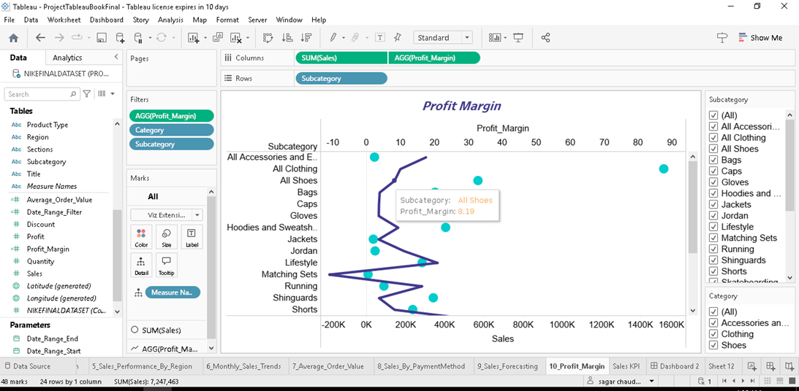

* The primary purpose of a dual axis chart is to provide a visual comparison of two related metrics that have different scales.
* Helps in identifying trends and patterns in the data by comparing metrics side by side.
* X-Axis (Horizontal Axis): Represents the common dimension, such as time (e.g., months, quarters, years).
* Primary Y-Axis (Left Vertical Axis): Represents the first metric, such as revenue.
* Secondary Y-Axis (Right Vertical Axis): Represents the second metric, such as profit margin.
* Data Series: Two data series are plotted on the chart, one for each metric. For example, revenue might be represented by bars, and profit margin by a line.

1. **DASHBOARD**
2. DASHBOARD 1:

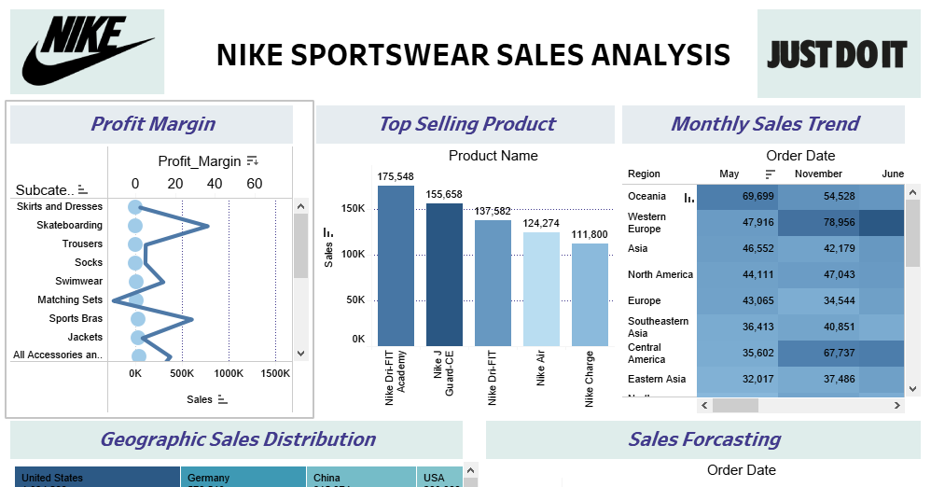

1. Header and Branding:

The dashboard includes Nike’s logo and the “Just Do It” slogan at the top to reinforce branding.

The title “Nike Sportswear Sales Analysis” is displayed prominently.

2. Profit Margin Analysis:

This section visualizes the profit margin for different subcategories of sportswear.

A dot plot chart represents profit margin values against different subcategories such as:

* Skirts and Dresses
* Skateboarding
* Trousers
* Socks
* Swimwear
* Matching Sets
* Sports Bras
* Jackets

The x-axis represents total sales volume, while the y-axis represents the different product categories. Higher profit margins indicate more profitable products, helping in strategic decision-making.

3. Top-Selling Products:

A bar chart displays the sales volume of the top-selling Nike products.

Product names on the x-axis include:

* Nike Dri-FIT Academy
* Nike J Guard CE
* Nike Air
* Nike Charge

The y-axis represents the total sales volume. The highest-selling product, Nike Dri-FIT Academy, has sales of 175,548 units, followed by Nike J Guard CE with 155,658 units.

4. Monthly Sales Trend :

A heatmap visualizes sales distribution across different regions and months. The columns represent months (May, November, June).

The rows represent different geographic regions, including:

* Oceania
* Western Europe
* Asia
* North America
* Europe
* Southeastern Asia
* Central America
* Eastern Asia

Darker shades indicate higher sales volumes, while lighter shades indicate lower sales.

For instance, Western Europe had strong sales in November (78,956 units), while Oceania had peak sales in May (69,699 units).

5. Geographic Sales Distribution:

A treemap visualizes sales distribution across different countries.

Larger blocks represent higher sales contributions from countries such as:

* United States (1,034,233 units)
* France (687,399 units)
* Germany (578,510 units)
* Australia (413,116 units)
* China (315,974 units)

Countries like India, Mexico, Indonesia, and Brazil contribute to smaller but significant portions of sales. This visualization helps identify top-performing markets.

6. Sales Forecasting:

A line chart with a trend projection visualizes historical sales data and future sales forecasts.

* X-axis represents the order date (years: 2012 - 2016).
* Y-axis represents total sales volume.

Key sales milestones include:

* 2012: 1,343,960 units
* 2013: 1,425,111 units
* 2014: 1,926,755 units
* 2015: 2,403,246 units
* 2016: 2,936,985 units

The shaded area indicates confidence intervals in forecasting. This section helps in predicting future demand and planning inventory accordingly.

1. DASHBOARD 2:

1. Key Performance Indicators (KPIs) displayed at the top:

* Total Sales: 7,247,463 units
* Total Profit: 1,044,989
* Total Products Sold: 30,088

These metrics provide an overview of business performance, indicating total revenue generated, overall profitability, and the total volume of products sold.

1. Sales Performance by Region

A horizontal bar chart displays sales volume across various regions:

* Western Europe
* Central America
* Oceania
* North America
* Asia
* Europe
* Southeastern Asia
* Southern Asia

The x-axis represents the sales volume. Darker-colored bars indicate higher sales contributions, while lighter bars represent lower sales figures. Western Europe has the highest sales volume, followed by Oceania and North America.

1. Sales by Payment Method:

A bubble chart represents the number of transactions completed using different payment methods.

Payment methods included:

* UPI: 2,534,164 transactions (Largest share)
* Cash on Delivery: 1,033,575 transactions
* Credit Card: 981,461 transactions
* Net Banking: 974,849 transactions
* PayPal: 983,300 transactions
* Debit Card: 740,115 transactions

Larger bubbles indicate higher transaction volumes.

4. Customer Demographics

* A pie chart represents customer segmentation based on gender and age.
* Segments include:
* Men: 17,033 customers (Largest segment)
* Women: 5,285 customers
* Kids: 6,473 customers
* Unisex: 1,297 customers

Men dominate the customer base, followed by kids and women.

5. Sales Trend Analysis

* A line chart represents monthly sales trends from 2012 to 2016.
* Different years are color-coded for easier trend identification.

Key observations:

* 2012: Sales fluctuated between 365 to 7,215 units.
* 2013: Sales peaked at 10,193 units.
* 2014-2015: More stable growth, with peaks around 12,965 to 14,381 units.
* 2016: A decline in sales toward the end of the period.

6. Average Order Value

A donut chart represents average order value across different years.

The central figure 96,397 represents the average order value.

Each segment shows how different years contributed to order values.

1. **BURNDOWN CHART**

The burndown chart illustrates the progress of task completion over time for a specific project.

1. Axs:

* The x-axis represents the timeline in days, covering the period from February 12 to February 19, 2025.
* The y-axis on the left represents the actual work remaining, ranging from 0 to 100.
* The y-axis on the right represents the planned work remaining, also ranging from 0 to 100.

2. Data Series:

* The blue line (Actual) represents the actual progress of work completed over time.
* The yellow-brown line (Planned) represents the expected or planned progress of work completion.

3. Observations:

* The project starts with one hundred units of work on February 12, 2025.
* Both the actual and planned lines follow a downward trend, indicating a reduction in remaining work overtime.
* There are slight variations where actual progress deviates from the planned progress, particularly on specific days:
* On February 14, actual progress is slightly behind the planned progress .
* On February 16, the actual progress and planned progress are closely aligned.
* By February 18, actual progress reaches near completion, aligning with the planned target.
* The project is fully completed on February 19, as both actual and planned values reach zero.

The actual progress initially lagged the planned progress but eventually caught up before completion. The burndown chart shows effective tracking of work, highlighting how deviations from the plan were corrected as the project progressed.

1. **KANBAN BOARD**

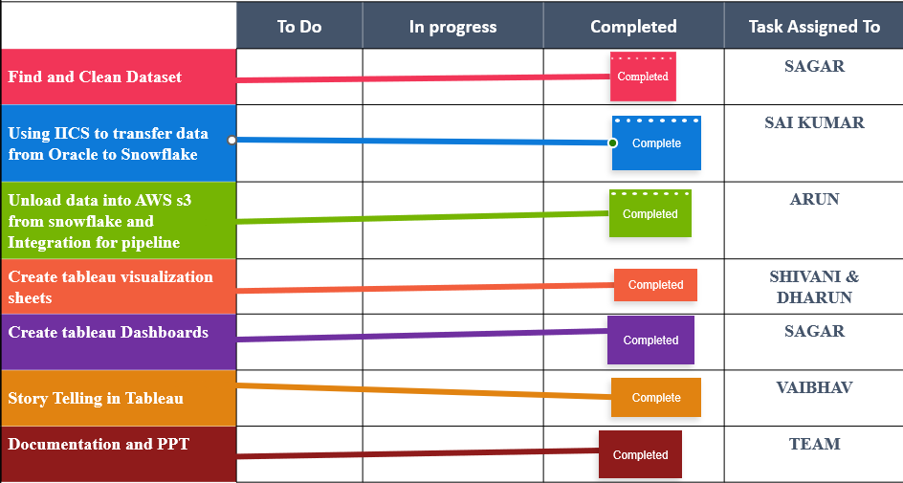

The Kanban chart provides a visual representation of the workflow for different tasks in a project. It helps track the progress of tasks across distinct stages—To Do, In Progress, and Completed—along with the team members assigned to each task.

The Kanban chart consists of the following columns:

1. To Do: Tasks that are planned but not yet started.

2. In Progress: Tasks that are currently being worked on.

3. Completed: Tasks that have been finished.

4. Task Assigned To: The names of individuals responsible for each task.

All tasks have reached the Completed stage. Team members are assigned specific tasks, ensuring clear responsibility. This visualization is useful for managing workload distribution and ensuring smooth task completion.

1. **CONCLUSION**

This project analyzed Nike’s sales data using advanced tools and techniques. Data was securely stored in AWS S3 and processed with Snowflake. Various visualizations provided insights into sales trends, top products, customer demographics, geographic distribution, and payment methods. Key charts included sales trends, top products, customer demographics, geographic sales, average order value, payment methods, monthly trends, profit margins, and sales forecasting. The analysis helps optimize sales strategies, aiding in strategic planning and decision-making for business growth and profitability.